What is the Netflix Zuul? Need for it?

Zuul is a JVM based router and server side load balancer by Netflix.   
It provides a single entry to our system, which allows a browser, mobile app, or other user interface to consume services from multiple hosts without managing cross-origin resource sharing (CORS) and authentication for each one. We can integrate Zuul with other Netflix projects like Hystrix for fault tolerance and Eureka for service discovery, or use it to manage routing rules, filters, and load balancing across your system.

* Microservice call without Netflix Zuul

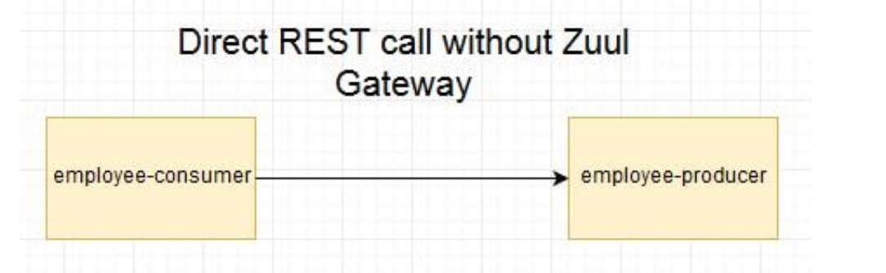

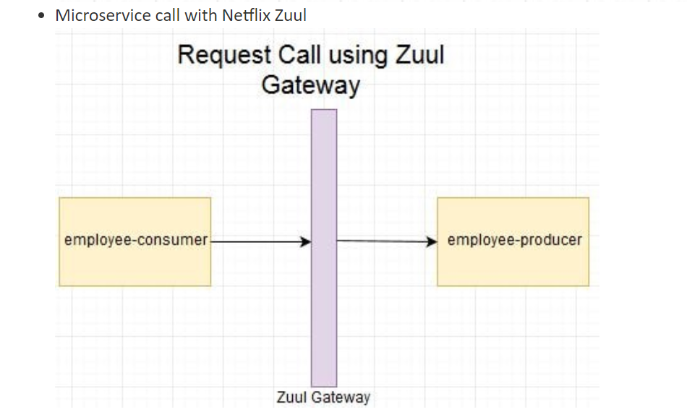

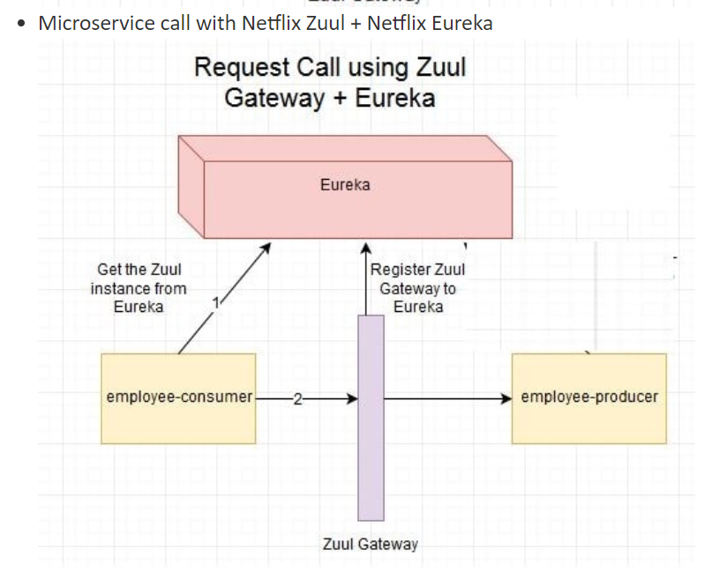

Implementation

**<dependency>**

**<groupId>org.springframework.cloud</groupId>**

**<artifactId>spring-cloud-starter-zuul</artifactId>**

**</dependency>**

Next define the following properties in application.properties-

zuul.routes.producer.url=http://localhost:8080

eureka.client.serviceUrl.defaultZone=http://localhost:8090/eureka

server.port=8079

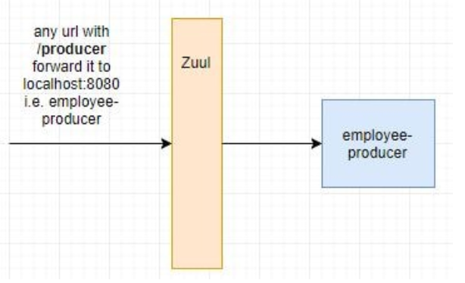

Here zuul.routes.producer.url will route incoming traffic to request for /producer to the employee-producer microservice. Similar routes can be added for other microservices as well.  
  
Next name the application module in the bootstrap.properties file

spring.application.name=employee-zuul-service